A2We Generating a grouped frequency distribution from raw data using SPSS

Raw data

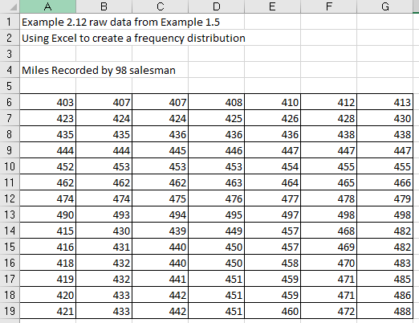
Figure 1

Result

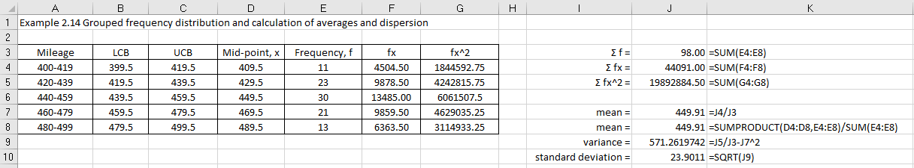
Figure 2

Step 1 Enter data into SPSS

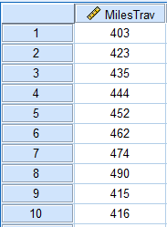
Figure 3

Select 2 Transform data using Visual Binning

Select Transform > Visual Binning
Transfer MilesTrav into the Variables to Bin box

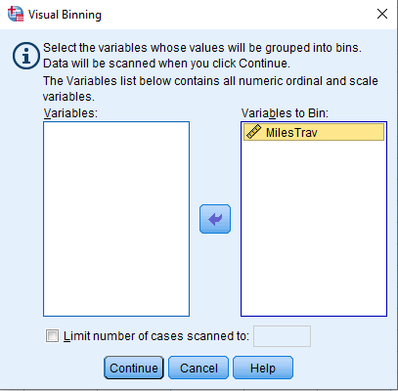
Figure 4
Click Continue

This gives you the Visual Binning dialog box.

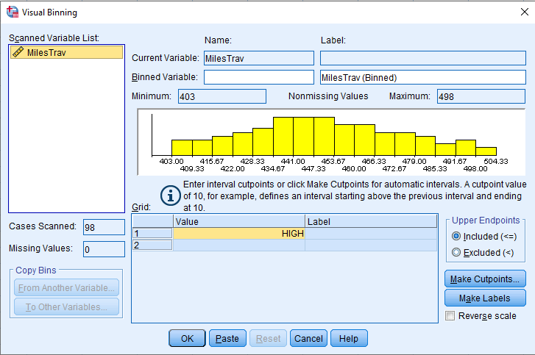
Figure 5

Type MilesTav_binned in the Binned Variable box

Type Miles travelled by 98 salesman (binned) in the Label box

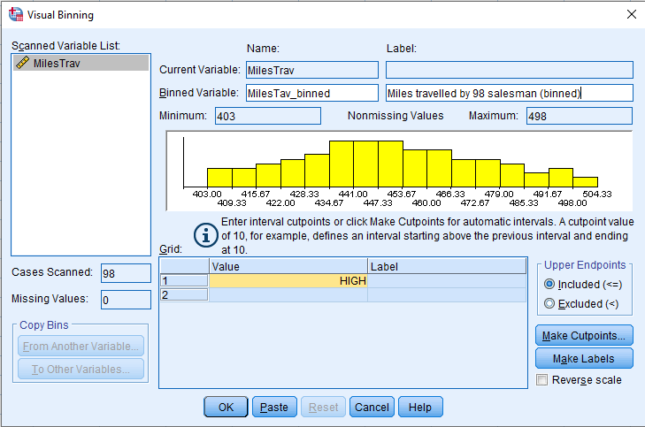
Figure 6

SPSS has already provided you with one cutpoint, HIGH. You provide the others.

- Put the cursor in the row below high and enter a new cutpoint. I entered 400. Hit Return.
- Move the cursor to the bottom row of the grid, enter another new cutpoint. I entered 500. Hit Return.
- Enter other values 420, 440, 460, 480, 500.
- Enter labels

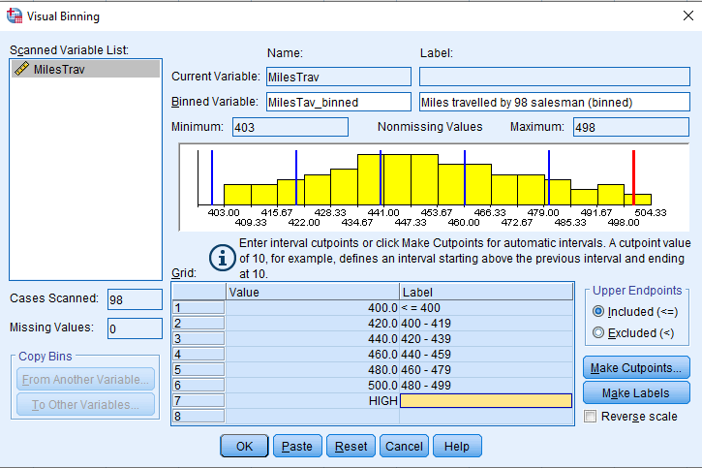
Figure 7

Now I decide that I want the first interval not to include the score of 400, the second interval not the score of 420, and so on. I click the Excluded button. SPSS warns me that the automatically generated labels are no longer correct. I delete those labels (highlight them, hit delete) and click “Make Labels” again.

Finally satisfied with the binning, I click OK.

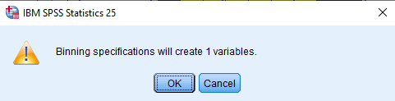
Figure 8

This will create a new variable within your SPSS data file.

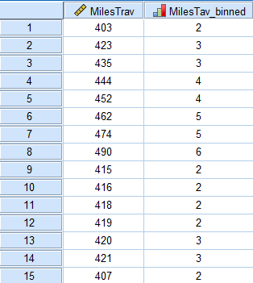
Figure 9

Step 2 Analyse this data variable

Creating the grouped frequency table

Select Analyze > Descriptive Statistics > Frequencies

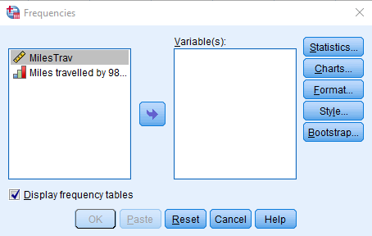
Figure 10

Transfer into the Variable(s) box

Now create the histogram

Click on Charts
Choose Histograms

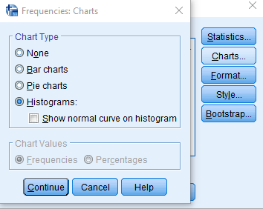
Figure 11
Click Continue

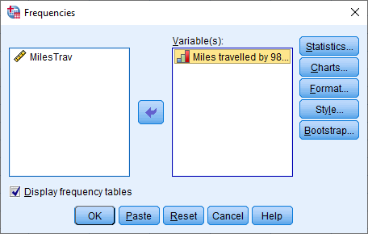
Figure 12

Click OK

SPSS output

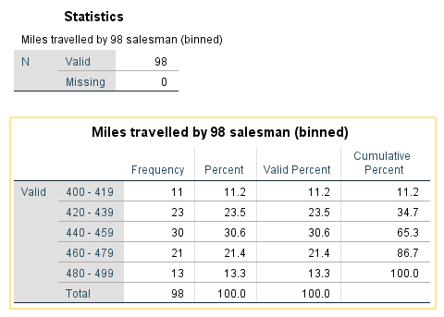
Figure 13

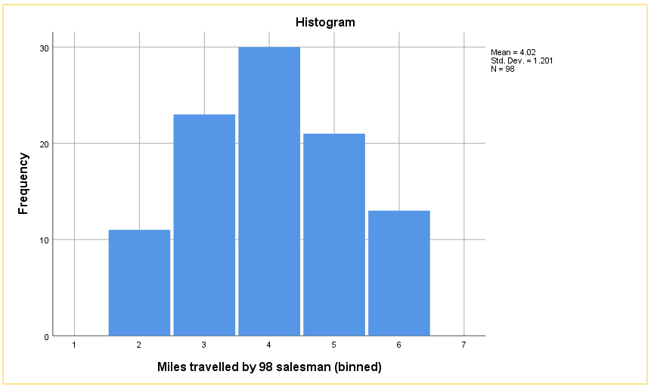
Figure 14

Double click on the graph to edit in SPSS

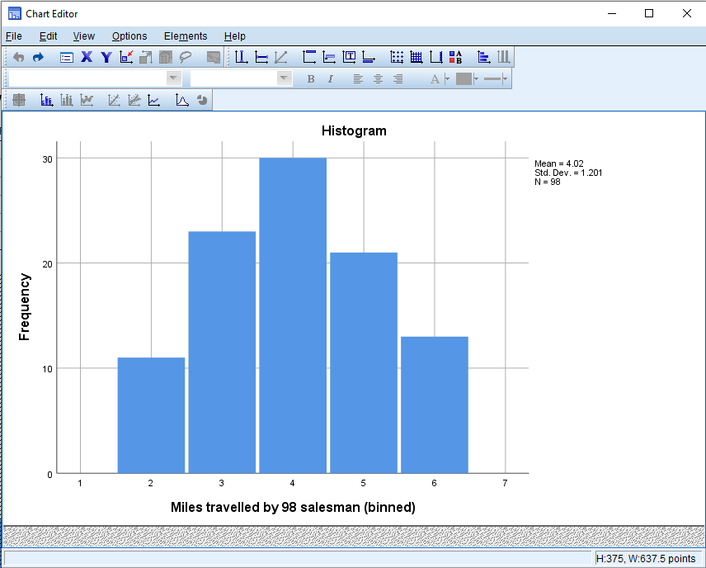
Figure 15

Double click on horizontal axis numbers.

Figure 16

This will open the Properties menu

Switch to Labels and Ticks and switch off Display labels, Click on Apply, Click on Close

Remove the legend, Click on Options > Hide Legend

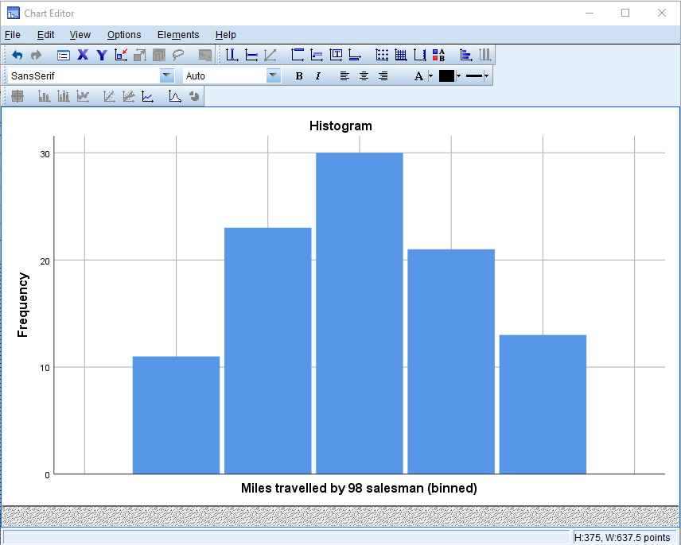
Figure 17

Click on File > Close

Finally, save the SPSS output file

The grouped frequency distribution would then be:

Class | Frequency
400 – 419 | 11
420 – 439 | 23
440 – 459 | 30
460 – 479 | 21
480 - 499 | 13

The histogram would then be

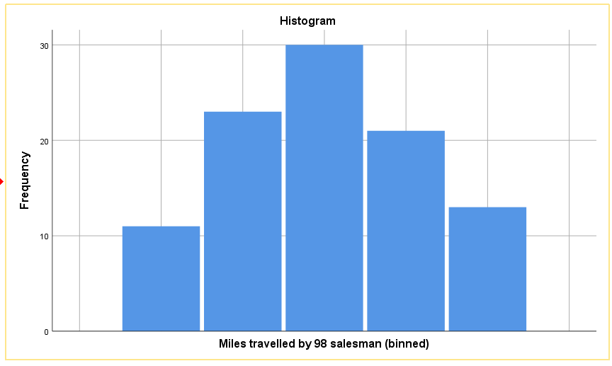
Figure 18

